**CPE 343 – Computer Organization & Architecture**



**Lab # 5**

**Title: Design the sequential circuit using advanced VHDL programming techniques**

|  |  |
| --- | --- |
| Name | Abdul Basit |
| Registration Number | FA17-BCE-062 |
| Class | FA17-BCE-B |
| Instructor’s Name | Moazzam Ali Sahi |

**INTRODUCTION:**

**Functions** are created in the VHDL to encounter the problem with code reusability,It is the sequential code. Functions are similar to process but it have two parts of it. Function body and function call. It can return a single value.

**Procedure** are kind of similar to the functions, but they return multiple values.

**PRE-LAB TASKS:**

**Task 1:**

1. VHDL Code

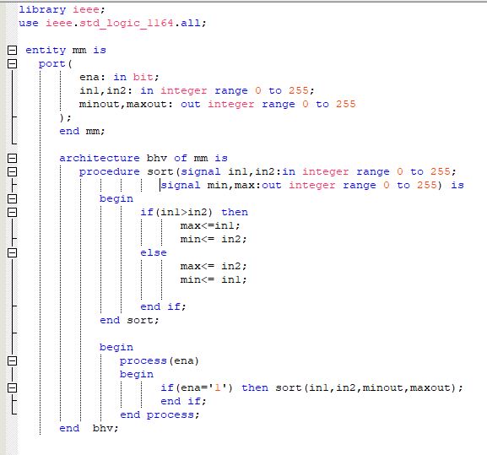

1. Results (VWF)

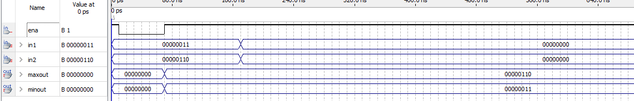

**LAB TASKS:**

**Task 1:**

1. VHDL Code

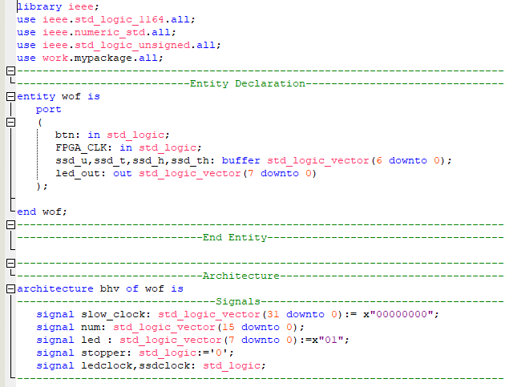

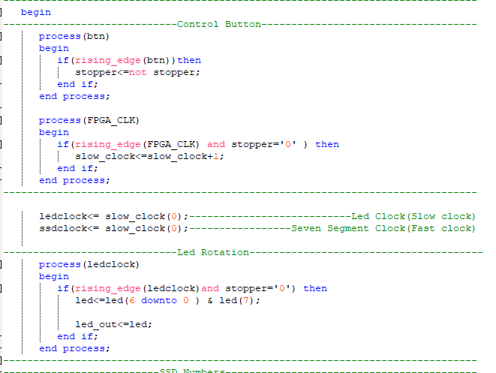

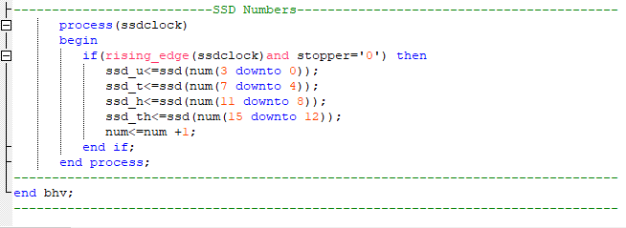

1. Results (VWF)

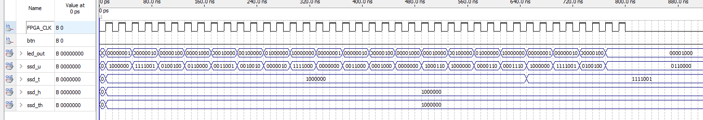

# CONCLUSION:

In this lab I learned how to use functions and procedures.